**PROGRAM 1 – SYSCALLS**

**Program 1:**

#include<stdio.h> #include<unistd.h> #include<stdlib.h>

int main()

{

int pid,pid1,pid2; pid=fork(); if(pid==-1)

{

printf("ERROR IN PROCESS CREATION \n");

exit(1);

}

if(pid!=0)

{

pid1=getpid();

printf("\n the parent process ID is %d\n", pid1);

}

else

{

pid2=getpid();

printf("\n the child process ID is %d\n ", pid2);

}

return 0;

}

**OUTPUT -**

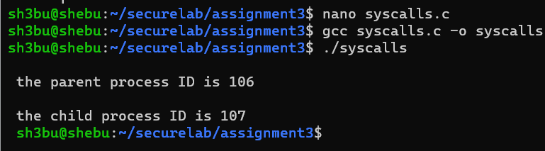

1. Write your own version of printf named myprintfunction().

A) It should be able to accept various types of parameters such as char, int, double, etc.

B) Bonus : The function should be able to accept different parameter count. The first parameter says the count of parameters, followed by actual parameters

#include <stdio.h>

#include <stdlib.h>

#include <stdarg.h>

#include <string.h>

char *_strrev (char *str)

{

int i;

int len = 0; char c;

if (!str) return NULL;

while(str[len] != '\0'){ len++;

}

for(i = 0; i < (len/2); i++)

{

c = str[i];

str [i] = str[len - i - 1];

str[len - i - 1] = c;

}

return str;

}

char * _itoa(int i, char *strout, int base)

{

char *str = strout; int digit, sign = 0; if (i < 0)

{

sign = 1;

i *= -1;

}

while(i)

{

digit = i % base;

*str = (digit > 9) ? ('A'+ digit - 10) : '0' + digit; i = i / base; str ++;

}

if(sign)

{

*str++ = '-';

}

*str = '\0';

_strrev(strout); return strout;

}

void myprintfunction(int n_args, ...)

{

va_list vl; int i = 0, j=0;

char buff[100]={0}, tmp[20]; char * str_arg;

va_start(vl, n_args);

const char *str = va_arg(vl, const char*);

printf("Total count of parameters given : %d\n", n_args);

while (str && str[i])

{

if(str[i] == '%')

{ i++;

switch (str[i])

{

case 'c':

{

buff[j] = (char)va_arg( vl, int ); j++;

break;

}

case 'd':

{

_itoa(va_arg( vl, int ), tmp, 10); strcpy(&buff[j], tmp);

j += strlen(tmp); break;

}

case 'x':

{

_itoa(va_arg( vl, int ), tmp, 16); strcpy(&buff[j], tmp);

j += strlen(tmp); break;

}

case 'o':

{

_itoa(va_arg( vl, int ), tmp, 8); strcpy(&buff[j], tmp);

j += strlen(tmp); break;

}

case 's':

{

str_arg = va_arg( vl, char* ); strcpy(&buff[j], str_arg);

j += strlen(str_arg); break;

}

}

}

else

{

buff[j] =str[i]; j++;

} i++;

}

fwrite(buff, j, 1, stdout); va_end(vl);

}

int main()

{

int n_args=5;

myprintfunction(n_args, "%c %d %o %x %s\n",'s', 007, 900, 2021,"Running with custom printf function");

return 0;

}

**OUTPUT –**

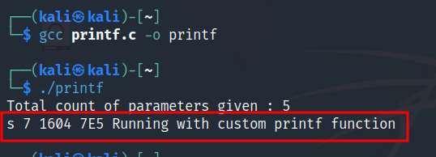

2. Write a program to read all txt files (that is files that ends with .txt) in the current directory and merge them all to one text file and return a file descriptor for the new file.

**PROGRAM -**

#include <dirent.h> #include <stdio.h> #include <string.h> int main(void)

{

DIR *cdir;

char *ptr1,*ptr2, filelist[100][100], temp[100], c; int retn, k=0;

char filename[100] = ("mergefile.txt"); struct dirent *dir;

cdir = opendir(".");

printf("Text files in the directory:- \n"); if (cdir)

{

while ((dir = readdir(cdir)) != NULL)

{

ptr1=strtok(dir->d_name,"."); ptr2=strtok(NULL,"."); if(ptr2!=NULL)

{

retn=strcmp(ptr2,"txt"); if(retn==0)

{

strcpy(temp, ptr1); strcat(temp, ".txt"); strcpy(filelist[k++], temp); printf("%s\n", temp);

}

}

}

closedir(cdir);

}

FILE *fptr1 = fopen(filename,"a"), *fptr2[k]; for(int i=k-1; i>=0; i--)

{

FILE *fptr2 = fopen(filelist[i], "r"); while((c = fgetc(fptr2)) != EOF) fputc(c, fptr1);

fclose(fptr2);

}

return 0;

}

**OUTPUT –**

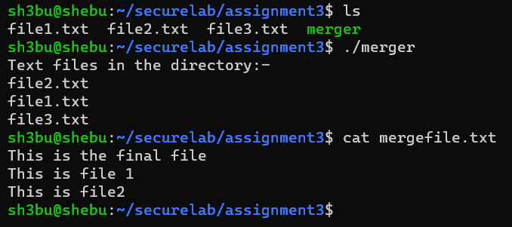

3. Write a program that will categorize all files in the current folder based on their file type. That is all .txt files in one folder called txt, all .bmp files in another folder called bmp etc. The argument to the program is a folder name.

PROGRAM –

#include<dirent.h>

#include <stdio.h>

#include <stdlib.h>

#include <string.h>

#include <sys/types.h>

#include <sys/stat.h>

#include <unistd.h>

int main(void)

{

DIR *cdir;

char *ptr1,*ptr2, ext[100][100], c; char filename[50], filepath[100]; for(int i=0; i<100; i++) strcpy(ext[i], "0");

int retn;

struct dirent *dir; cdir = opendir("."); if (cdir)

{

while ((dir = readdir(cdir)) != NULL)

{

ptr1=strtok(dir->d_name,"."); ptr2=strtok(NULL,"."); if(ptr2!=NULL)

{

if(strcmp(ext[ptr2[0]-97], "0") == 0)

strcmp(ext[ptr2[0]-97], ptr2);

strcpy(filename, ptr1); strcat(filename, "."); strcat(filename, ptr2); mkdir(ptr2, 0755); strcpy(filepath, ptr2); strcat(filepath, "/"); strcat(filepath, filename);

FILE *fp1 = fopen(filepath, "w");

FILE *fp2 = fopen(filename, "r"); while((c = fgetc(fp2)) != EOF) fputc(c, fp1);

}

}

closedir(cdir);

}

return 0;

}

**OUTPUT –**

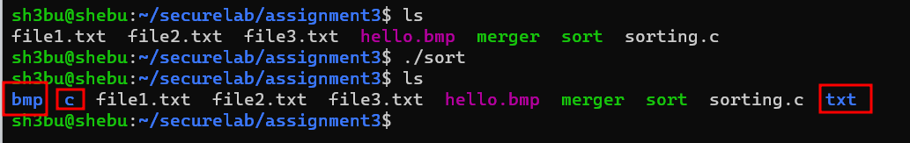

4. Given a directory, write a program that will find all files with the same name in the directory and its sub directories. Show their name, which folder they are in and what day they were created. Expand the program to remove all duplicate copies based on user input. That is, ask the user if each one of the files is to be kept or deleted. Based on user input, perform the appropriate action

**PROCEDURE -**

#include <stdio.h>

#include <sys/types.h>

#include <dirent.h>

#include <stdlib.h>

#include <string.h>

char dirnames[100][100][100]={0}; int tree(const char *path, int level)

{

int k=1;

struct dirent *dp;

DIR *dir = opendir(path); if (!dir)

return 0;

while((dp = readdir(dir)) != NULL)

{

if (strcmp(dp->d_name, ".") != 0 && strcmp(dp->d_name, "..") != 0) strcpy(dirnames[level][k++], dp->d_name);

}

closedir(dir); return k;

}

int main()

{

static int k=0, arr[100]; struct dirent *dp;

int choice;

char ch1, name1[10]={0}, name2[10]={0}, command[50]={0}; char *basepath = "/Desktop/cprogm";

printf("\nChoose the operation\n\n"); printf("1. Listing Directories in tree view\n"); printf("2. Remove Duplicate files\n"); printf("3. Exit\n\n");

printf("Enter the choice: "); scanf("%d", &choice); if(choice == 1)

{

system("tree -D");

}

if(choice == 2)

{

system("tree -D");

DIR *dir = opendir("."); if(!dir)

return 0;

while((dp = readdir(dir)) != NULL)

{

char *ptr1=strtok(dp->d_name, "."); char *ptr2=strtok(NULL, ".");

if (strcmp(dp->d_name, ".") != 0 && strcmp(dp->d_name, "..") != 0 && ptr2==NULL)

{

strcpy(dirnames[k++][0], dp->d_name);

}

}

for(int i=0; i<k; i++)

arr[i] = tree(dirnames[i][0], i); for(int i=0; i<k-1; i++)

{

for(int j=1; j<arr[i]; j++)

{

for(int x=i+1; x<k; x++)

{

for(int y=1; y<arr[x]; y++)

{

if(strcmp(dirnames[i][j], dirnames[x][y])==0)

printf("%s %s have duplicate files in %s\n", dirnames[i][0], dirnames[x][0], dirnames[i][j]);

}

}

}

}

printf("\n\nDo you want to remove any of the files(y/n): "); scanf(" %c", &ch1);

if(ch1 == 'y' || ch1 == 'Y')

{

int flag=1;

printf("\nEnter the directory name of duplicate file: "); scanf("%s", name1);

printf("\nEnter the filename: "); scanf("%s", name2);

for(int i=0; i<k; i++)

{

if(strcmp(dirnames[i][0], name1)==0)

{

flag=0; break;

}

}

if(flag)

{

printf("Directory not found\n"); exit(0);

}

for(int i=0; i<k; i++)

{

for(int j=1; j<arr[i]; j++)

{

if(strcmp(dirnames[i][j], name2)==0)

{

flag=0; break;

}

}

}

if(flag)

{

printf("File not found\n"); exit(0);

}

else

{

char temp[100]={0}; strcpy(command, "rm "); strcpy(temp, basepath); strcat(temp, name1); strcat(temp, "/"); strcat(temp, name2); strcat(command, temp);

int stat = system(command); if(!stat)

printf("%s from %s successfully removed..!\n", name2, name1); exit(0);

}

}

}

if(choice == 3)

{

exit(0);

}

return 0;

}

**OUTPUT –**

